Course: MAI511-1 - Advanced Database Technologies
LAB Exercise – IV Normalization
OTT PLATFORM MANAGEMENT SYSTEM
Tables:
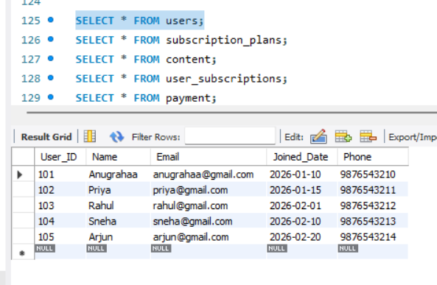

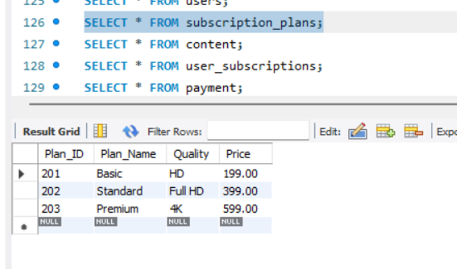

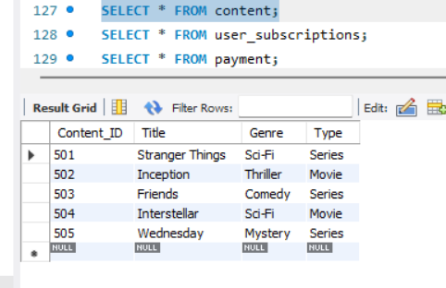
Name: Anugrahaa V
Roll No. 2648506

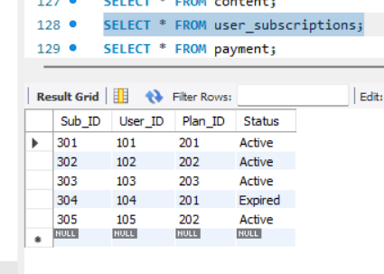

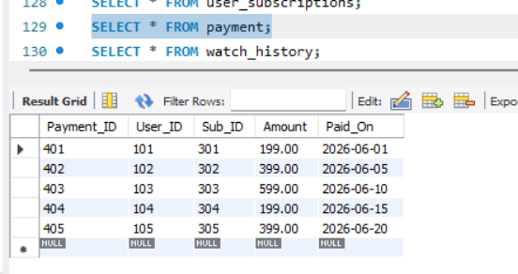

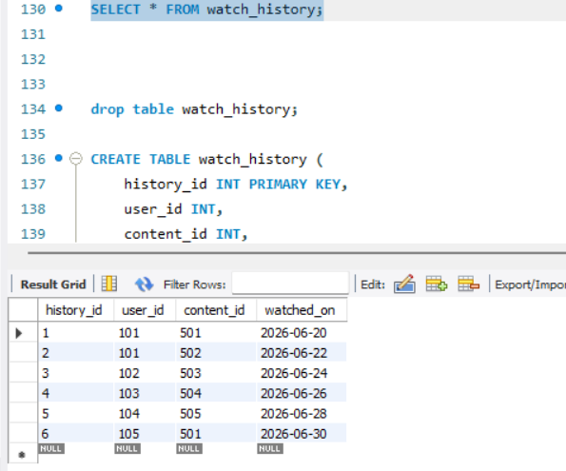

CREATING AN UNORMALIZED TABLE
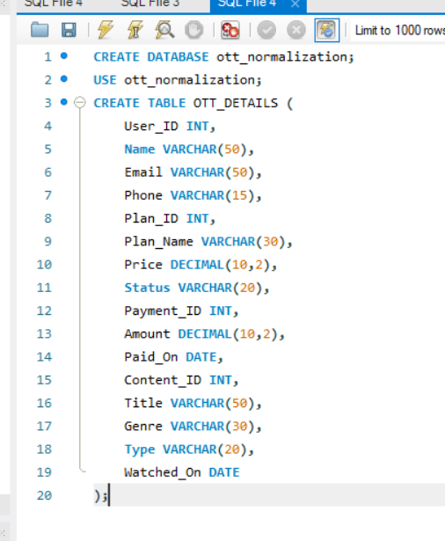
The existing project database is already normalized into multiple related tables. To demonstrate the normalization process, a new relation named OTT_DETAILS was created by combining user, subscription, payment, and content information into a single table. This combined table contains repeated data and functional dependencies, making it suitable for normalization.
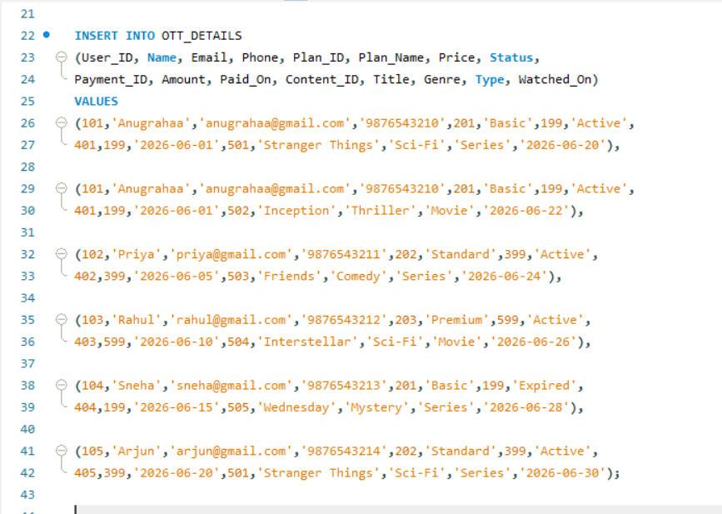
Unnormalized Form
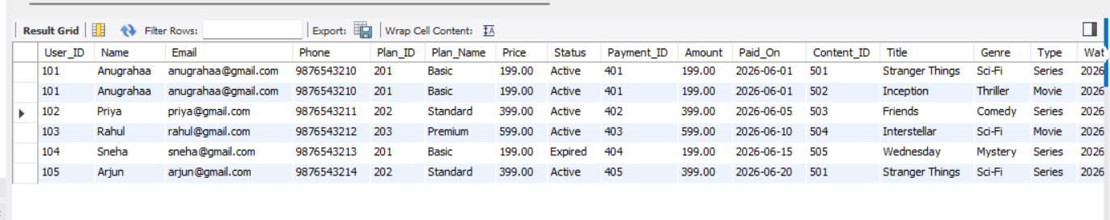
Description
The OTT_DETAILS table combines user, subscription, payment, and content details into a single relation. Since the same user and subscription information appears repeatedly for multiple watched contents, the table contains redundancy. This makes it suitable for normalization.
Justification
For example:
- Anugrahaa appears twice.
- Basic plan appears twice.
- Payment 401 appears twice.
This repetition is called data redundancy.

ANALYSIS OF UNNORMALIZED TABLE (OTT_DETAILS)
- Primary Key
A primary key is a column (or combination of columns) that uniquely identifies each row.
Primary Key: (User_ID, Content_ID)
User_ID | Content_ID
101 | 501
101 | 502
102 | 503
103 | 504
104 | 505
105 | 501

- User_ID repeats.
- Content_ID also repeats (a movie can be watched by many users).
But User_ID + Content_ID together identify each record uniquely.
So we choose:
(User_ID, Content_ID)
2. Candidate Key
A candidate key is any column (or set of columns) that can uniquely identify a record.
Candidate Key: (User_ID, Content_ID)
Because it can uniquely identify every row.
3. Functional Dependencies
If one column determines another column, then there is a functional dependency.
- User_ID → Name, Email, Phone
- Plan_ID → Plan_Name, Price
- Payment_ID → Amount, Paid_On
- Content_ID → Title, Genre, Type

4. Data Redundancy
Redundancy means the same data is stored repeatedly.
User information, subscription details, and payment details are repeated for users who have multiple watch history records. This causes unnecessary duplication of data.
5. Update Anomaly
Suppose Anugrahaa changes her phone number.
You must update every row where Anugrahaa appears.
If you forget one row,
one row shows
9876543210
another shows
9999999999
Database becomes inconsistent.
Updating repeated information requires changes in multiple rows. Missing one update leads to inconsistent data.
6.Insert Anomaly
New content cannot be inserted without user and payment details.

7.Delete Anomaly
Deleting a row may remove important related information.

First Normal Form (1NF)

The OTT_DETAILS table satisfies First Normal Form because every attribute contains atomic (single) values. There are no repeating groups or multivalued attributes. Each record represents one user watching one content.
Justification
Since every column stores only one value and the logical primary key (User_ID, Content_ID) uniquely identifies each record, the relation satisfies First Normal Form.
(2NF) SECOND NORMAL FORM
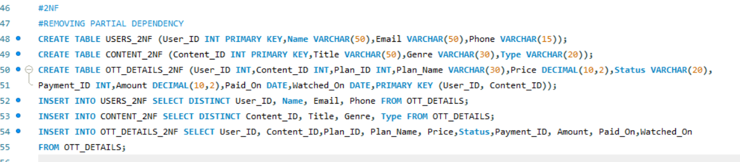
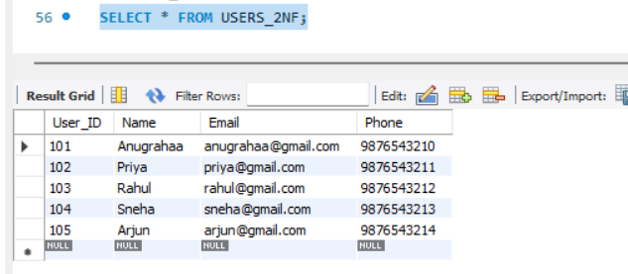
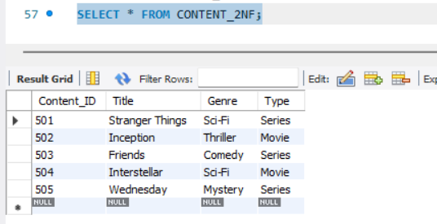
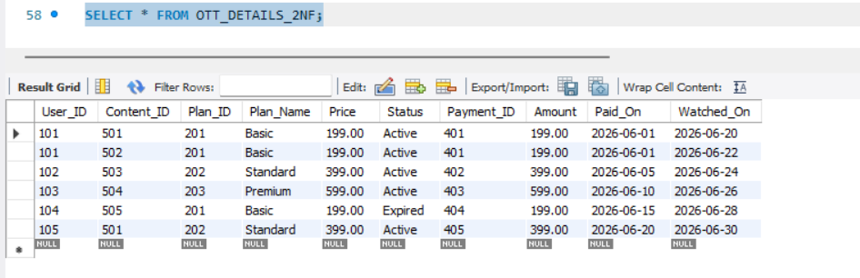
Explanation
In 2NF, partial dependencies are removed. Attributes that depend only on a part of the composite primary key are moved into separate tables. User details are stored in USERS_2NF, content details are stored in CONTENT_2NF, and the remaining relationship data is stored in OTT_DETAILS_2NF.
Justification
Since Name, Email, and Phone depend only on User_ID, and Title, Genre, and Type depend only on Content_ID, these attributes were separated into different tables to eliminate partial dependency.
Third Normal Form (3NF)
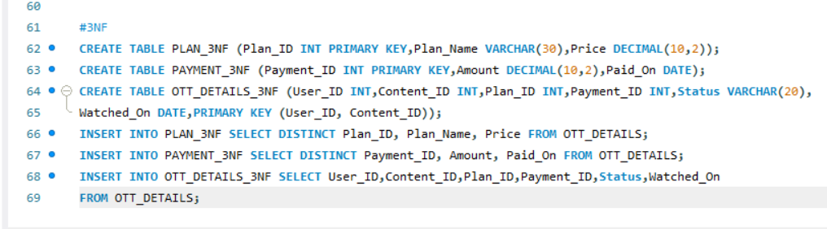
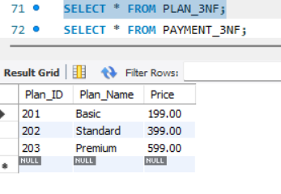
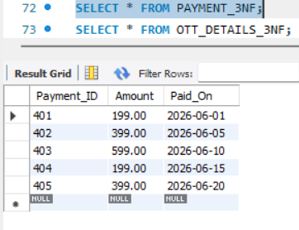
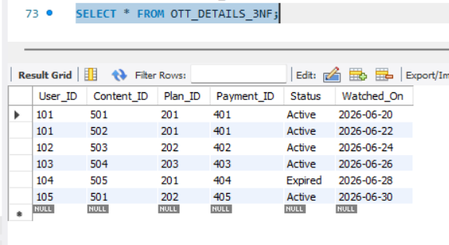
Explanation
In 3NF, transitive dependencies are removed. Plan details and payment details depend on Plan_ID and Payment_ID respectively, not directly on the primary key. Therefore, they are moved into separate tables.
Justification
Plan_Name and Price depend on Plan_ID, while Amount and Paid_On depend on Payment_ID. Separating them eliminates transitive dependencies and improves data integrity.
UNNORMALIZED DATABASE TABLE
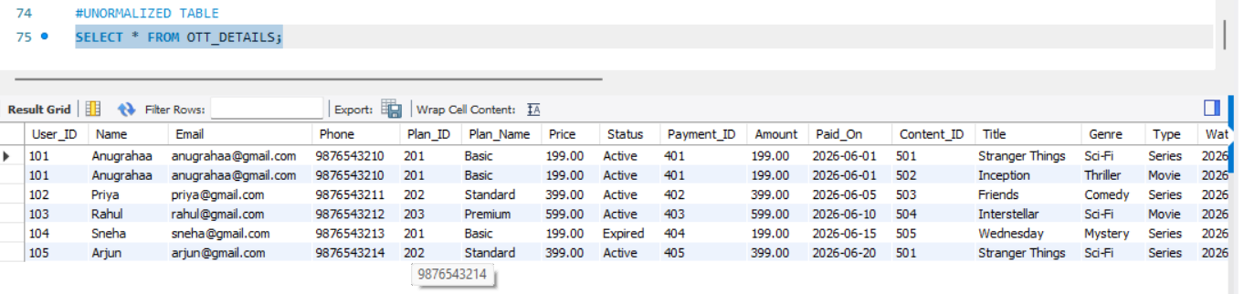
NORMALIZED DATABASE TABLE
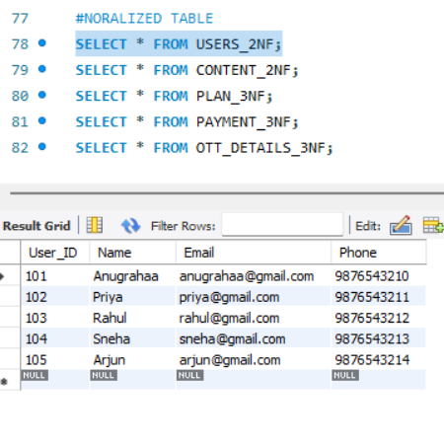
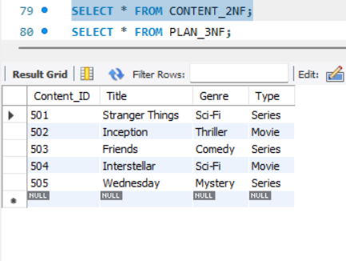
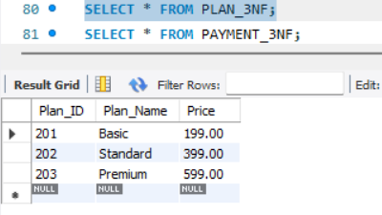
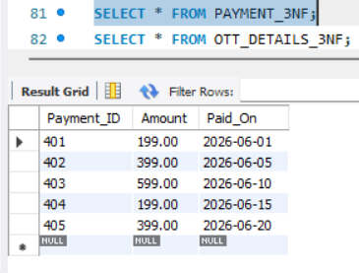
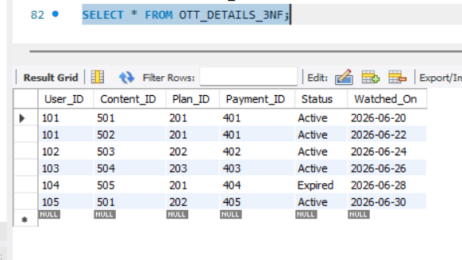
UNNORMALIZED Database Design
The original database design consists of a single table (OTT_DETAILS) that stores user, subscription, payment, and content information together. This design contains redundant data and is prone to update, insert, and delete anomalies.
Normalized Database Design
The normalized database design separates user, content, plan, payment, and relationship information into different tables. This removes redundancy, improves consistency, and minimizes anomalies.

COMPARE SQL OPERATIONS
1. INSERT Operation
Before Normalization
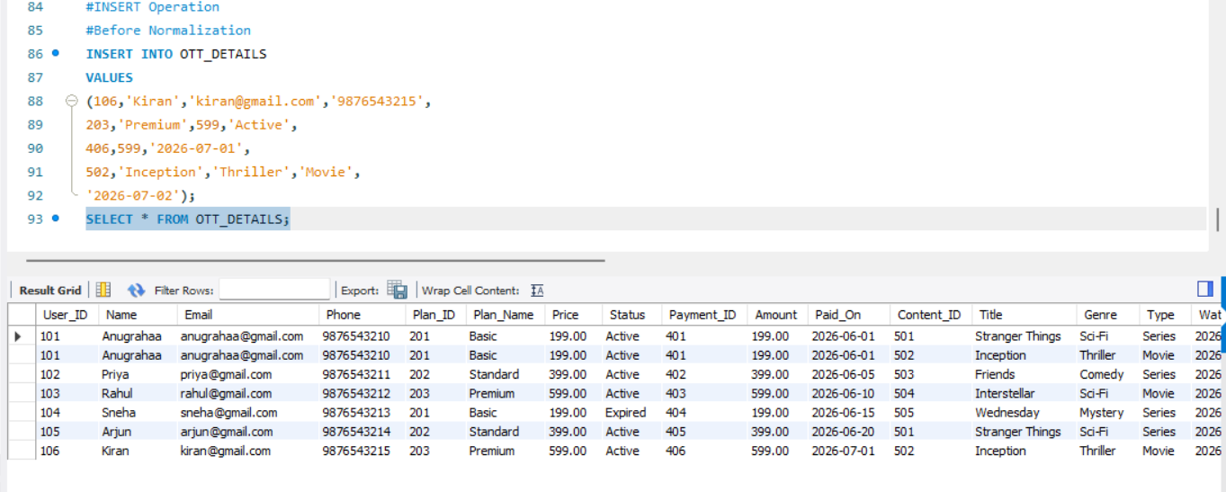
After normalization
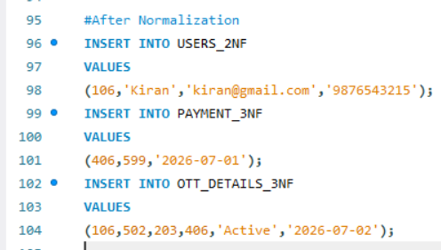
2.UPDATE OPERATION
Before Normalization
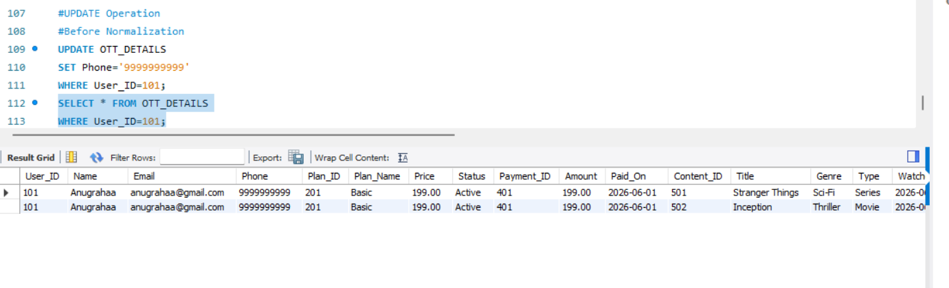
After Normalization
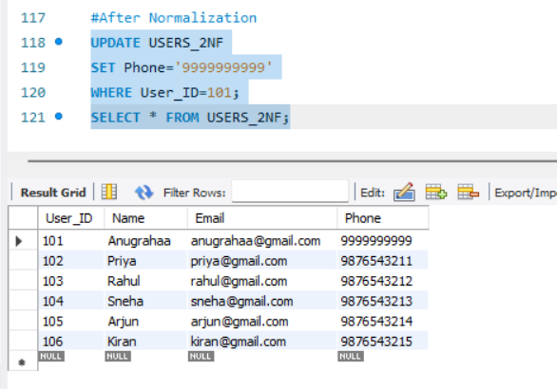
3. DELETE Operation
Before Normalization
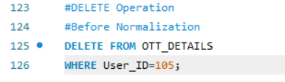
After Normalization
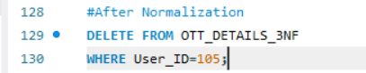
4. Retrieval using JOIN
Because data is split into different tables after normalization, use a JOIN to reconstruct the information.
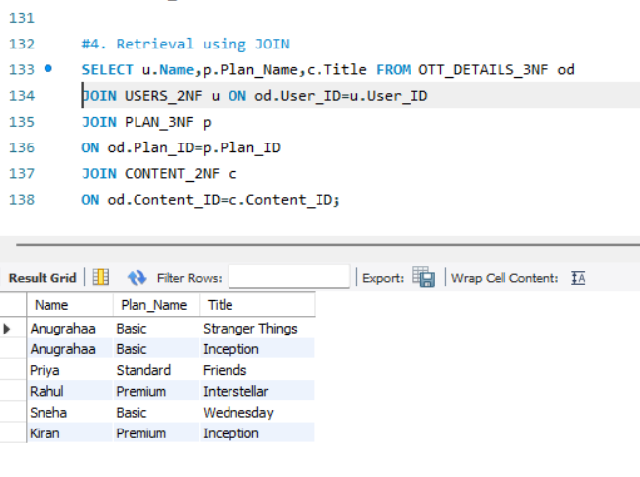
EFFICIENCY COMPARISON TABLE
Parameter | Before Normalization | After Normalization
Number of Tables | 1 | 5
Data Redundancy | High | Low
Storage Usage | High | Low
Update Anomaly | Present | Removed
Insert Anomaly | Present | Removed
Delete Anomaly | Present | Removed
Data Consistency | Low | High
Query Complexity | Simple | Moderate (requires JOINs)

